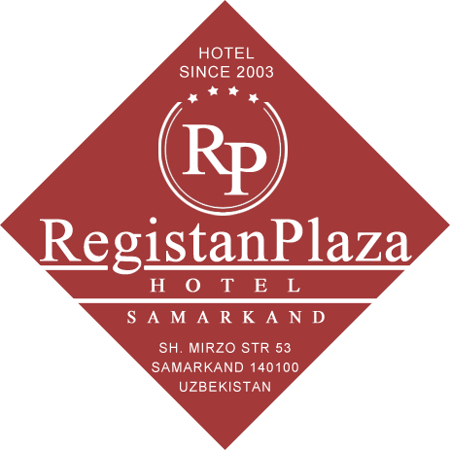

**REGISTAN PLAZA HOTEL**

**Choose best one**

Team members:

Yadgarova Aylisa (U1710298)

Ismoilova Nargiza (U1710302)

Durjanova Sevinch (U1710305)

Sadullaeva Madina (U1710306)

Brief information:

**Registan Plaza Hotel** C:\Users\Firuz-PC\AppData\Local\Microsoft\Windows\INetCache\Content.Word\rating.png

Registan Plaza Hotel is one of the amazing hotels of Samarkand. Hotel Registan Plaza is conveniently located in the city center and it is close to both business and historical parts of the city. This hotel has been running its business since 2003 and so far it has been named President Hotel in 2017, its name is transferred in Registan Plaza. Its key business is serving guests of Samarkand, especially tourists by offering good services and convenient rooms. Due to its good location and services, this hotel grabs many customers and it is rated by four stars. The customers of this hotel are guests (tourists, businesspersons, visitors etc.). Customers can visit hotel’s website easily, get all information about the hotel. If they are not satisfied or they do not understand something, they can visit contact page and send mail to hotel manager. Besides, if they want to book a room they first check date interval when they come and leave. Having a check, they will be able to take more details about available rooms and can book them. All registrations, bookings, messages (from customers) and room availabilities are controlled by administration and there are admins who can enter admin page (server side) by their logins and passwords. One room may be booked by different customers twice or more, in a such kind of situations Admins control room availabilities, for example if some rooms are reserved, those rooms must be removed from available rooms list. Moreover, If any customer who have a problem with booking a room then admins can also register them to booking rooms. In addition, Hotel has another comfort such as ”Hot Line” which is sevring 24 hours for answering customers’ calls.

Screenshots of Home page

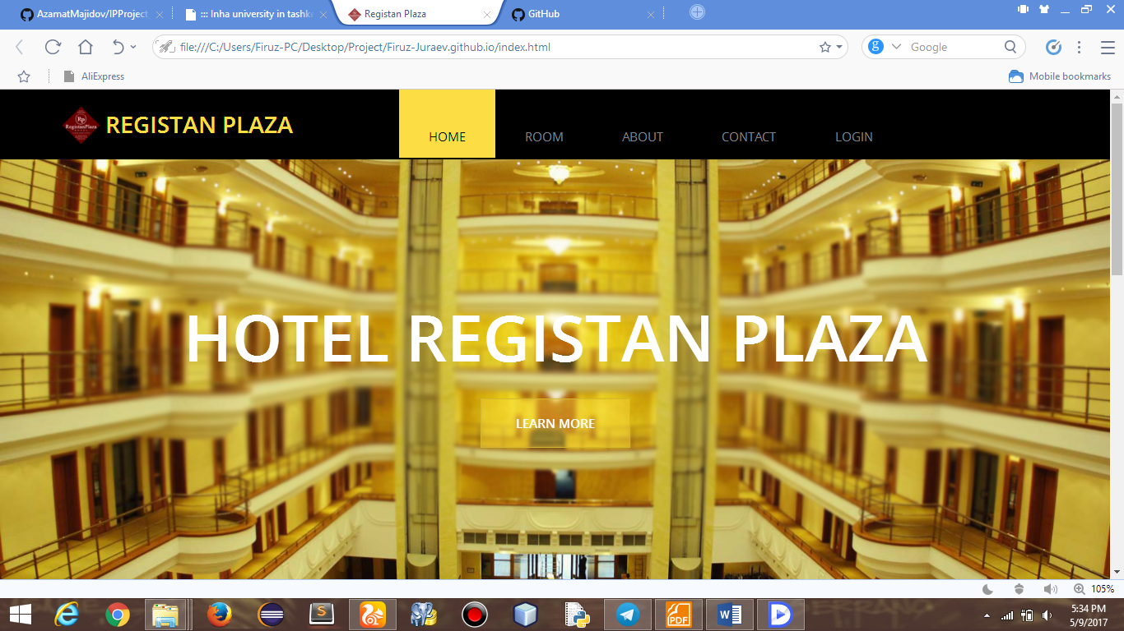

By choosing a date of coming and leaving customers can see if there are any free rooms for booking.

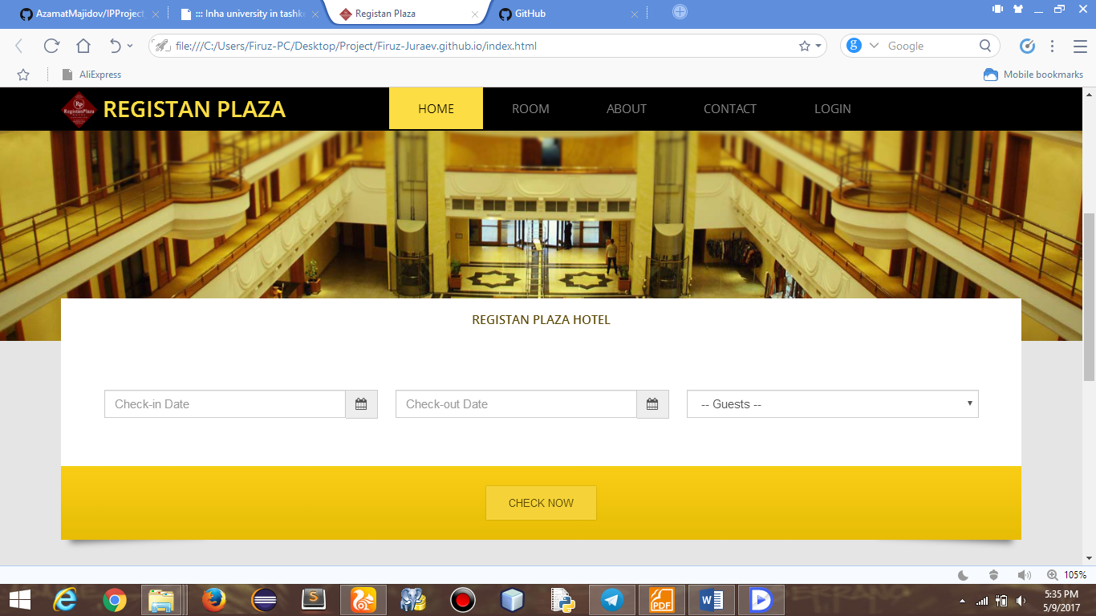

Here, customers can observe kind of rooms which hotel offers.

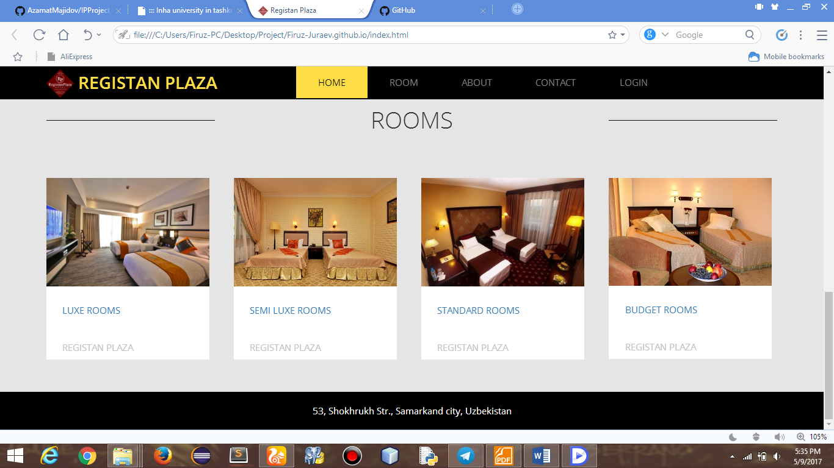

The Client can see brief information about the above four types of rooms by clicking just one of them.

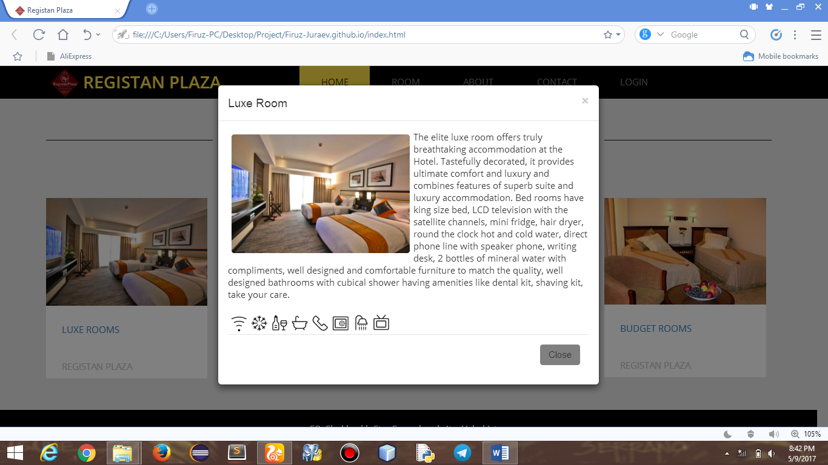

Screenshots of page

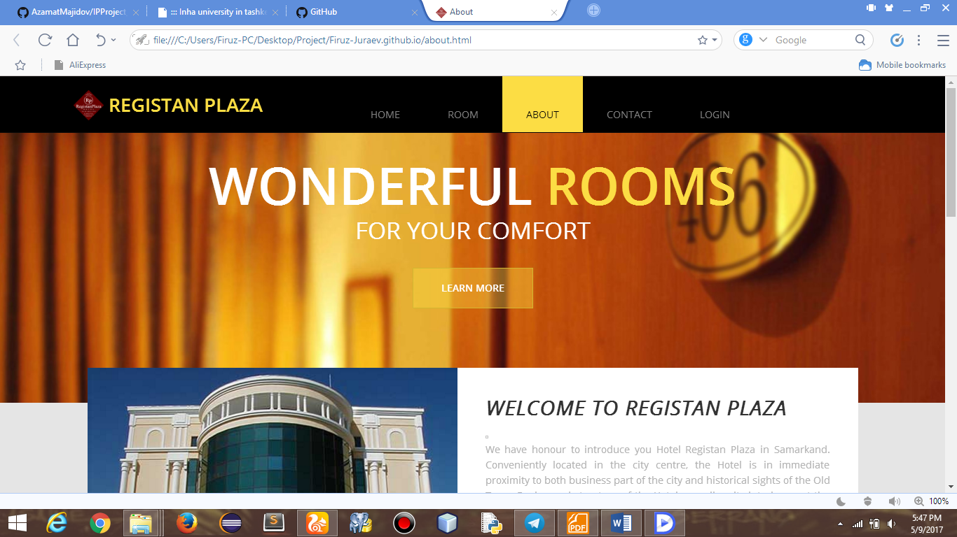

There are consumer can be got some info related to the hotel.

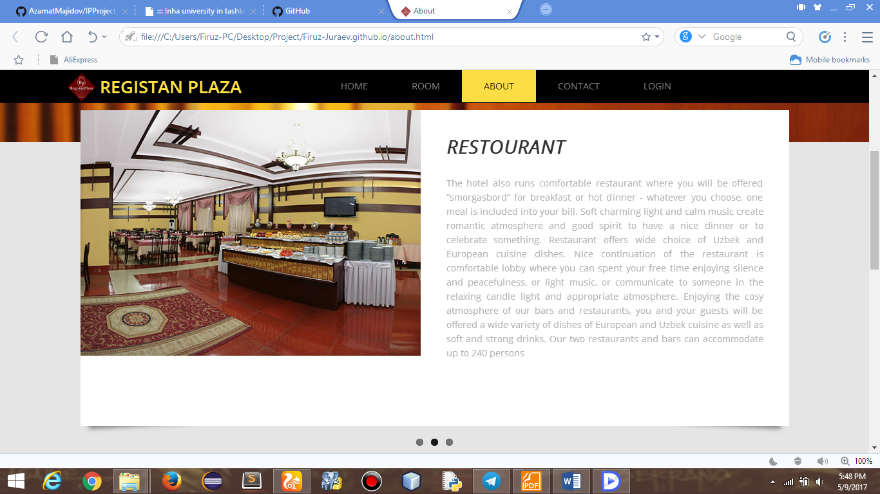

Screenshots of contact page

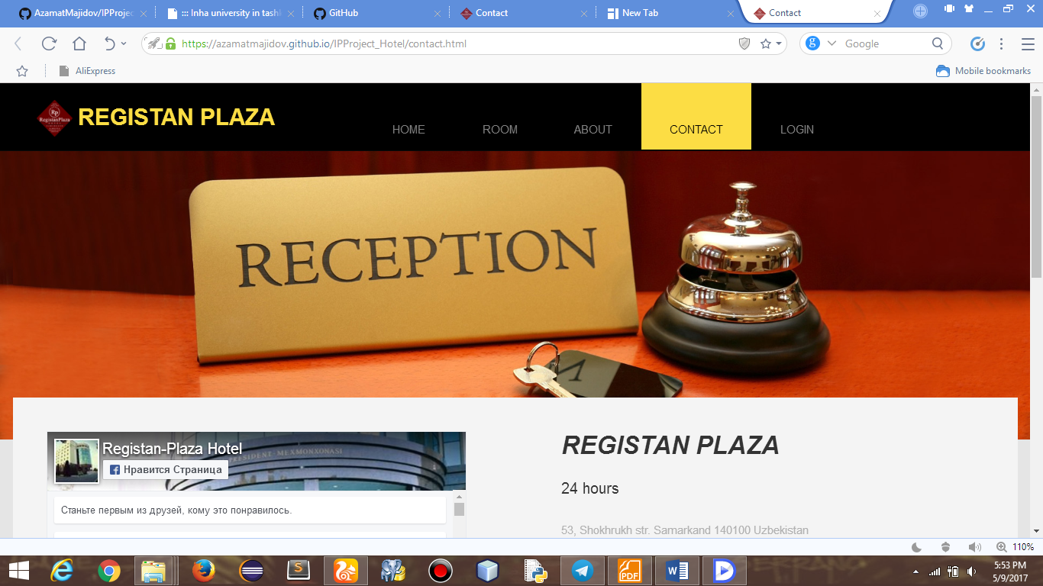

Also available addresses, mail, phone number of the hotel to contact easily.

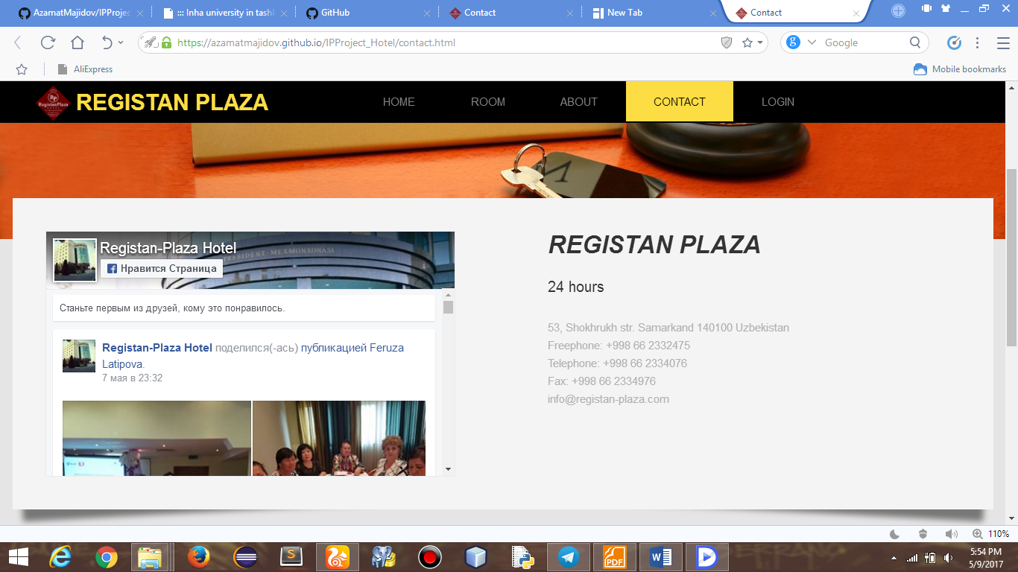

Another facility is checking a location of the hotel from map, and send email to the administration if cunsomers have a question. In screenshot email not sent because of invalid email address.

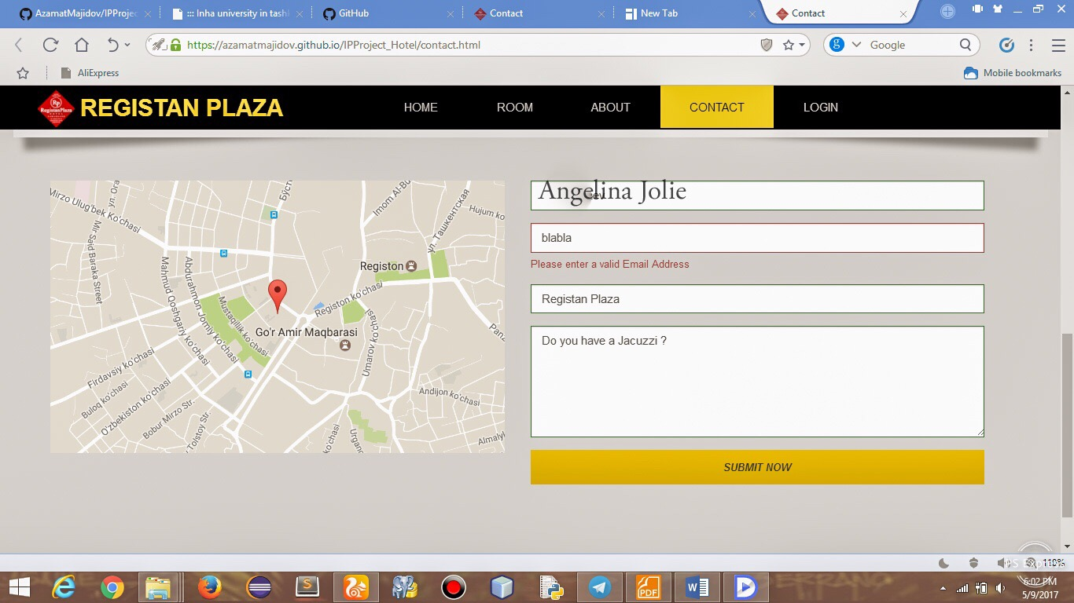

There are the mail is sent successfully.

Screenshots of registration page

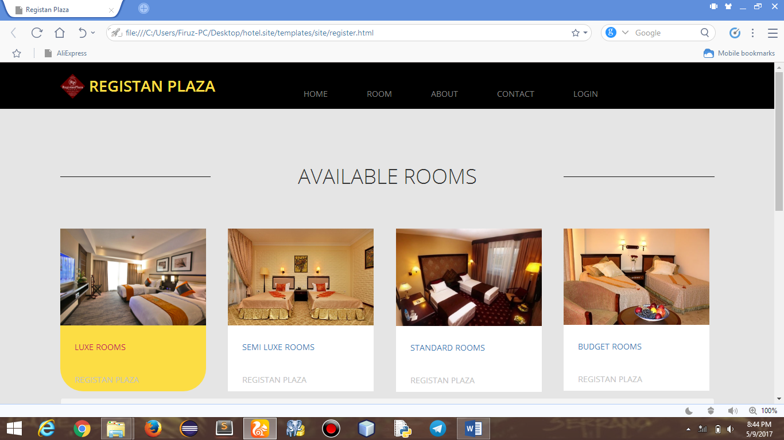

Here page of booking rooms.

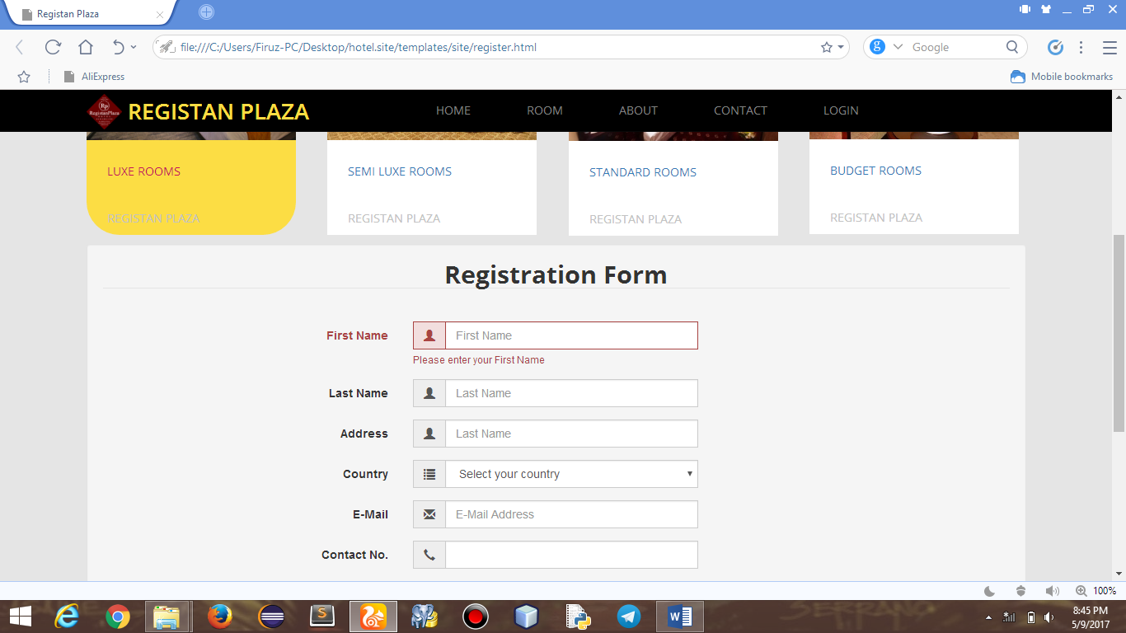

There are you can see the whole registration form. (Choosing country)

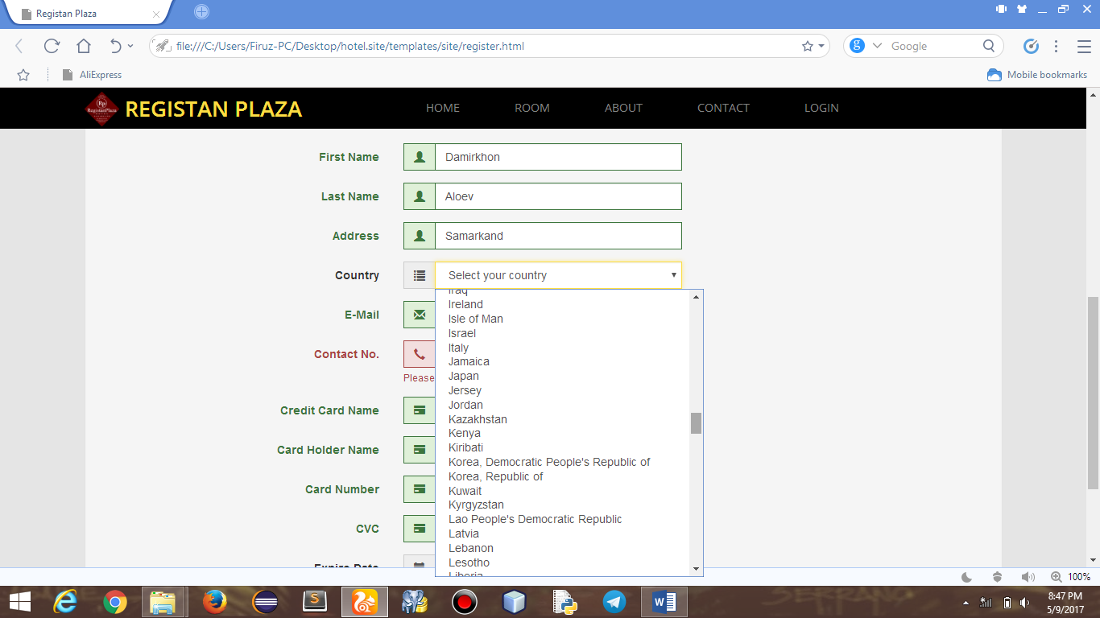

All inputs are clearly identified and user will not make any mistake because if there will be a mistake it will alert you with red border there you can see contact number is wrongly chosen.

Submit successfully.

In addition, we have a dashboard which is for manager for controling Check-in Check-out of guests and also can create new users. All pages are responsive…

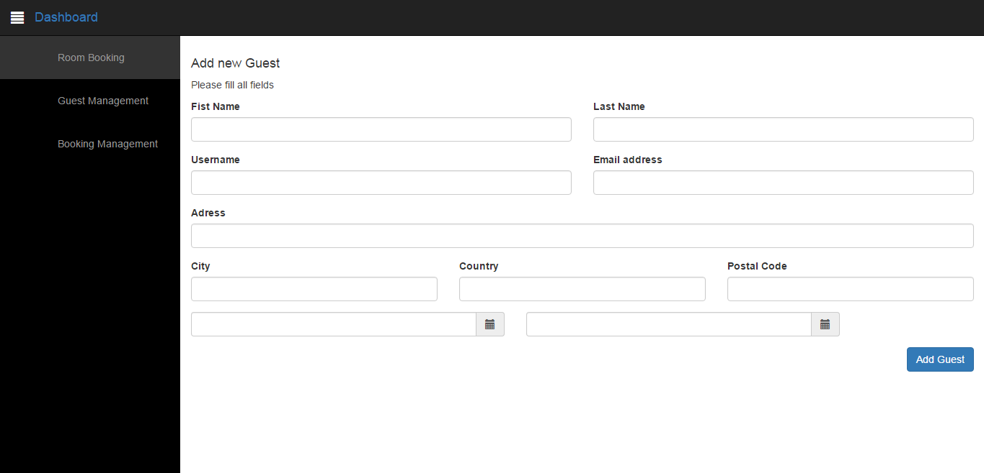

<https://github.com/aylisa/Registan_hotel>

https://registan.000webhostapp.com/hotel/templates/